Step 0 Intake + Interview Filing Status, Dependency

Interview Notes: (See also: General Notes)
The McCooks own a home. They paid $11,000 in property taxes for the year. Block: 49 Lot: 2. They are eligible and file a homestead benefit application
They do not have a Mortgage.
Troy McCook is a Veteran
Robert McCook is still in High School.

Documents:
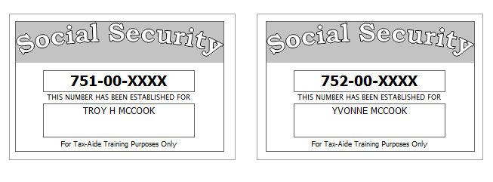
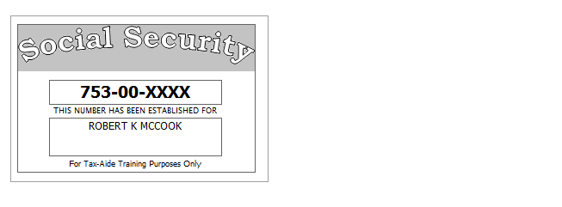

Step 1 Basic Information

TP Form / Note | TS Screen | Notes
SS Card | Start a New 2017 Tax Return  Available Taxpayer Profiles | Ignore the Profiles  Select “Enter Social Security Number” at the bottom of the screen  Enter the TP SSN twice and “Start Return”
Intake Sheet | What is your filing Status? | Answer: Filing Status: Married filing jointly  Continue
SS Card  Intake Sheet | Personal Information  Taxpayer Information  Spouse Information  Address & Phone Number | TS: Enter all information using “Caps Lock”.  Hint: Use Name and SSN from SS card. (Not Intake Sheet)  Hint: SSN format YYY-00-0752  TS: Birth date can be entered using drop down menu or filling in the field.  TS: Check any of the “Check here” questions that apply –  Hint: Check here if the Spouse wishes to contribute $3 to the Presidential Election Campaign Fund  TS: Spouses last name auto populates when field is selected. Change if required.  TS: Enter Zip code- TaxSlayer fills in city and state. Correct if required  TS: Enter New Jersey as the Resident State  TS: Select Continue
Intake Sheet  G-Note 2,3 | New Jersey Return | Hint: Begin NJ Checklist  TS: Select Municipality from drop down menu (Listed by county). Paterson is in Passaic County. Start typing Passaic to quickly scroll down  TS: Answer question regarding dependent Health Insurance. Answer is Yes.  TS: Select Yes or No for the Gubernatorial Election Fund. See Intake Sheet page 3 and General Note 3.  Answer: No for TP, Yes for SP.  TS: Five Digit Pin for TP and SP is automatically selected  TS: Select Continue
 | Dependents/ Qualifying Person(s)  Do you have any Dependents or Qualifying Person(s) to claim on your return? | TS: Answer is “Yes”.
 | Dependent/Qualifying Child  Information | Add dependent information  Hint: Use name and SSN from SS card (Not Intake Sheet)  TS: The last name auto populates. Change if required  Answer: SSN format = YYY-00-0752  Check the “Check if” questions that apply  Answer: Robert is a full-time student but he is not over 18.  TS: Continue - Continue

Federal AGI: 0 Federal Refund: 0 NJ Refund Amount: 0

Step 2 SSA-1099 Troy & Yvonne McCook
TP Form / Note | TS Screen | Notes
SSA-1099 | Left Menu -Federal Section-Income  IRA/Pension Distribution Form 1099-R/RRB/SSA  - Begin  Social Security Benefits/RRB-1099 -Begin | Enter SSA-1099 Data  Hint: Use TP4F Scratch Pad to document Medicare Parts B, C, D. Insert total in “Taxpayer’s Medicare Premiums”. Amount = $1,619  TS: Continue, Continue

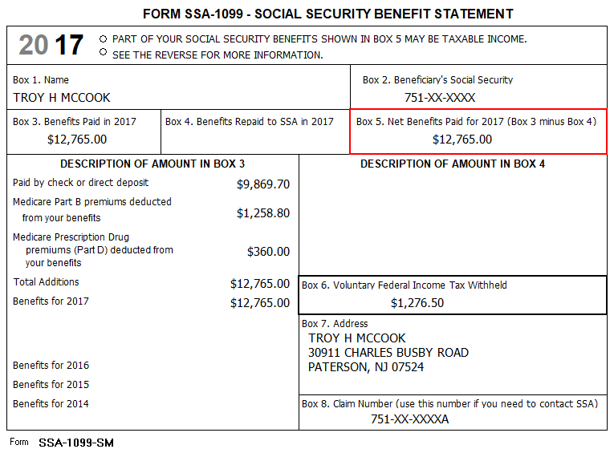

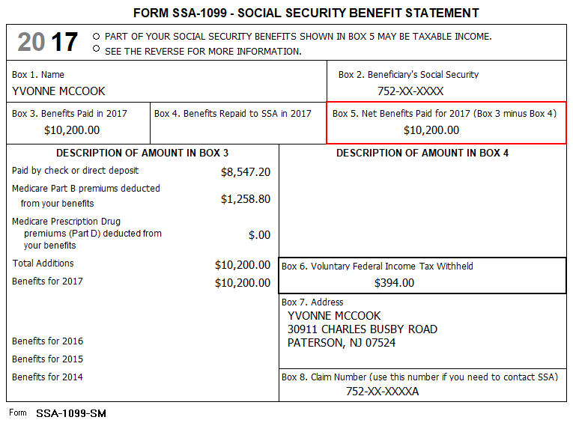

Federal AGI: 0 Federal Refund: 1671 NJ Refund Amount: 0

Step 3 Dividends 1099-DIV - Oppenheimer
TP Form / Note | TS Screen | Notes
1099-DIV  Oppenheimer | Left Menu- Federal Section -Income  Interest and Dividends Form 1099-INT/1099-DIV –  Begin  Interest or Dividend Income – Begin  Dividend Income, Form 1099-DIV-Continue  Continue | Hint: Select for Taxpayer  Enter values that apply  Continue Until Back to Income
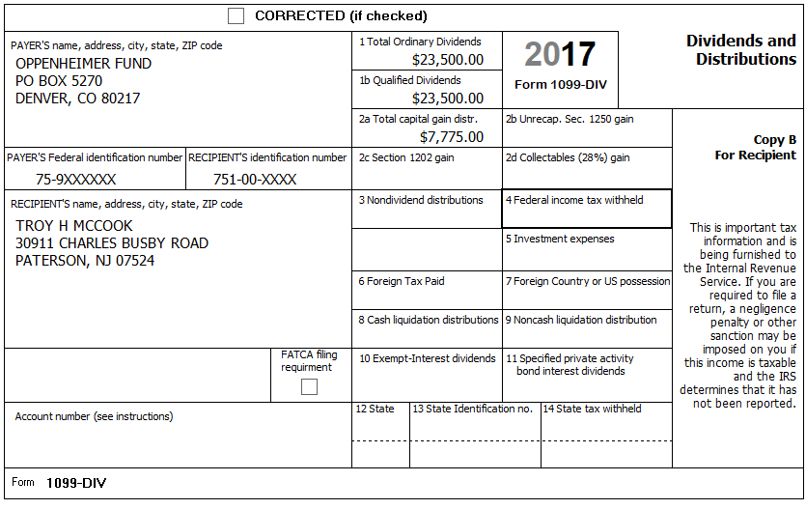

Federal AGI: 36,654 Federal Refund: 1,671 NJ Refund Amount: 0

Step 4 1099-R Ameritech

TP Form / Note | TS Screen | Notes
1099-R  Ameritech | Left Menu-Federal Section – Income  IRA/Pension Distribution Form 1099-R / RBA, SSA – Edit  Add or edit a 1099-R  Begin | Hint: “This 1099-R is for Troy  Hint: Make corrections so that information matches the information on the 1099-R  Hint: Taxable amount defaults to Gross Distribution Amount. Adjust as required.  Hint: Did you check the Taxable Amount Not Determined Box?  TS: You do not have to select a State for income to go to the State return.  TS: Save & Enter Another

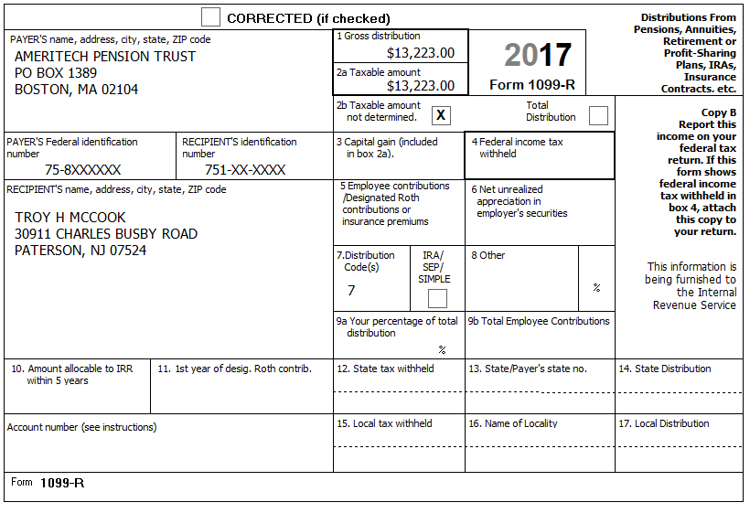

Federal AGI: 60,682 Federal Refund: 1,465 NJ Refund Amount: 0

Step 5 1099-R Phoenix

TP Form / Note | TS Screen | Notes
1099-R  Phoenix Investments |  | Hint: “This 1099-R is for Yvonne  Hint: Make corrections so that information matches the information on the 1099-R  Hint: Taxable amount defaults to Gross Distribution Amount. Adjust as required.  Hint:  Did you check the IRA/SEP/Simple Box?  TS: You do not have to select a State for income to go to the State return.  TS: Continue

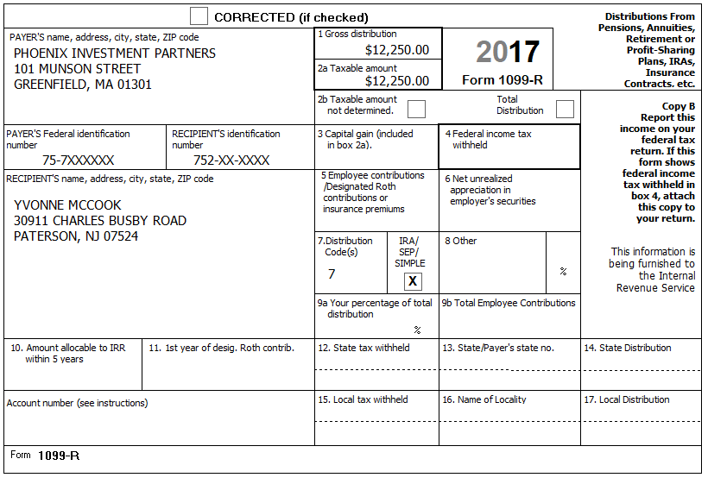

Federal AGI: 76,268 Federal Refund: -92 NJ Refund Amount: 0

Step 6 Itemized Deductions – Taxes You Paid
TP Form / Note | TS Screen | Notes
I-Note 4 | Left Menu-Federal Section -Deductions – Enter Myself  Itemized Deductions – Begin  Taxes You Paid - Begin | TS: Go to the AddSales Tax Worksheet and enter NJ and 365 days living in NJ  TS: Continue - Continue  TS: Enter real estate taxes paid  Continue Until Deductions

The McCooks own a home. They paid $11,000 in property taxes for the year. They do not have a Mortgage

Federal AGI: 76,268 Federal Refund: -92 NJ Refund Amount: 0
Step 7 Compare Standard vs Itemized Deductions

TP Form / Note | TS Screen | Notes
 | Federal Section  Deductions  Enter Myself  Compare Deductions - Begin | Check to see if using itemized deductions or standard deductions.  Itemized = 11,900  Std = 15,200  Continue

Federal AGI: 76,268 Federal Refund: -92 NJ Refund Amount: 0
Step 8 Health Insurance

TP Form / Note | TS Screen | Notes
G-Note 2 | Left Menu  Health Insurance  Start Questionnaire | Answer questions in the Health Insurance Section

Every person on the return had health insurance that met Minimum Essential Coverage rules for the entire year. They did not purchase it through the marketplace.

Federal AGI: 76,268 Federal Refund: -92 NJ Refund Amount: 0
Step 9 New Jersey Return
TP Form / Note | TS Screen | Notes
I-Note 1  G-Note 2,3,4 | State Return –Edit  Basic Information - Edit  Credits  - Property Tax/Deduction-Begin | Hint: Use the NJ Checklist to enter NJ items  TS: Check Basic Information –  Answer: TP is a Veteran  Save  TS: Credits – Begin  TS: Property Tax Credit/Deduction - Begin  Hint: Property Taxes Paid = $11,000  Hint: Taxpayer meets Property Tax Eligibility Requirements  Hint: TP was a Homeowner in 2017  Hint: County Property located in: Passaic County-Paterson  Save back to the beginning of the State Return

They had no out-of-state purchases on which they did not pay Use tax
The McCooks own a home. They paid $11,000 in property taxes for the year. Block: 49 Lot: 2.
They are eligible and file a homestead benefit application
They do not have a Mortgage
Federal AGI: 76,268 Federal Refund: -92 NJ Refund Amount: 0
Step 10 Prepare for e-file
Intake Sheet  G Note 5 | Left Menu – e-file – | TS – Clear up any diagnostic messages (if any)  TS: Select Federal Return Type “E:file: Mail Payment”  Next  TS: No entries in Fees section except for Client email address  TS – Pin numbers for e-file are automatically selected  Next  TS: Select State Refund Type “E:file: Mail Payment”  Next  TS: Skip Third Party Designee Info  Next  TS: Consent to Disclose Tax Return Information – Check DENY and enter 5 digit pin ( any 5 digit number) and date for TP and SP  Next  TS – Questions – Answer questions from Intake sheet Part VII, lines 5.6 and 7  Next  TS: Skip TP ID Information Screen  Save  You are Done

They want to handle any state refund / amount due like their federal refund / amount due

Federal AGI: 76,268 Federal Refund: -92 NJ Refund Amount: 0

